**module ROM_v1 (cs, addrb, datab, read_en);**

**input [2:0] addrb;**

**output [7:0] datab;**

**input read_en, cs;**

**reg [7:0] datab;**

**always @ (addrb)**

**if (read_en & cs)**

**case (addrb)**

**0: datab = 21;**

**1: datab = 255;**

**2: datab = 33;**

**3: datab = 99;**

**4: datab = 127;**

**5: datab = 13;**

**6: datab = 10;**

**7: datab = 88;**

**endcase**

**else**

**datab = 8'bz;**

**endmodule**

**module tst_ROM_v1;**

**reg [2:0] addrb;**

**wire [7:0] datab;**

**reg read_en, cs;**

**ROM_v1 rom1 (cs, addrb, datab, read_en);**

**initial begin**

**#0 addrb = 2;**

**#10 addrb = 5;**

**#10 addrb = 3;**

**#5 addrb = 7;**

**end**

**initial begin**

**#3 cs <= 1;**

**end**

**initial begin**

**#3 read_en <= 1;**

**end**

**endmodule**

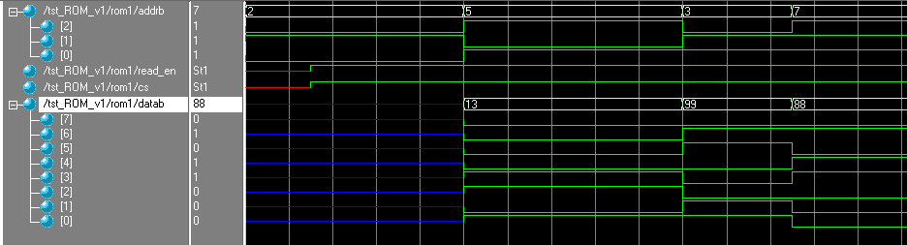

**module ROM_v2 (cs, addrb, datab, read_en);**

**input [2:0] addrb;**

**output [7:0] datab;**

**input read_en, cs;**

**reg [7:0] datab;**

**always @ (*)**

**if (read_en & cs)**

**case (addrb)**

**0: datab = 21;**

**1: datab = 255;**

**2: datab = 33;**

**3: datab = 99;**

**4: datab = 127;**

**5: datab = 13;**

**6: datab = 10;**

**7: datab = 88;**

**endcase**

**else**

**datab = 8'bz;**

**endmodule**

**module tst_ROM_v2;**

**reg [2:0] addrb;**

**wire [7:0] datab;**

**reg read_en, cs;**

**ROM_v2 rom1 (cs, addrb, datab, read_en);**

**initial begin**

**#0 addrb = 2;**

**#10 addrb = 5;**

**#10 addrb = 3;**

**#5 addrb = 7;**

**end**

**initial begin**

**#3 cs <= 1;**

**end**

**initial begin**

**#3 read_en <= 1;**

**end**

**endmodule**

